**PGE 392K – Reservoir Simulation**

**Project 2 2D 2 Phase**

**Due Dec 3**

**HOMEWORK SUBMISSION GUIDELINES**

**An automated workflow is utilized in the grading process. Please read carefully to meet the submission guidelines**

Upload all items below to canvas in a single **.zip file** (not .rar or other extensions) named (Your Last Name, Your First Name). The content of the main (zipped) folder should be as follows:

* 1. Homework Powerpoint Template.
  2. a PDF file of additional items to submit such as written notes and whatever you wanted to add to the ppt file but couldn't.
  3. a PDF file of scanned signed cover sheet
  4. A folder that contains all your other files

1. Notes on filling the PowerPoint solution template:
   * 1. **Do not add or remove slides.**
     2. Use a reasonable number of significant figures
     3. Make sure you use proper limits for your plots (including 2D plots) with proper labels for axis, color bars, legend and title.
     4. Wherever you are asked to submit screenshots, use your judgment to decide which parts of your code/ written notes are the most important and take screenshots of that.
2. Notes on the content of the homework files folder:
   1. You do not need to compress this folder separately. Just compress the main folder
   2. Main items: (PPT file and PDFs of coversheet and additional notes should be in the main folder, not in subfolders.
   3. The codes should be clearly labelled (ex Q1A, Q2B.. etc) and they should run. Make sure that you have everything needed to run the codes. You should test it before you send it.
3. **Upload a PDF of this cover sheet after signing the waiver below:**

**I verify that I have I completed this homework on my own accord. I have not used homework solutions from a previous semester of 392K. If I worked in a group, I contributed my share and I am confident I could re-do the homework entirely on my own. By signing my name, I verify that these statements are true and if it is found that they are not true, it may result in a severe penalty (F in the course and reported to Dean of Judicial Affairs)**

Signature ___________________

Printed Name__________________ EID____________

Model Development: Write a program to solve for the time and spatially-varying pressures for the multi-phase (oleic phase and water phase) flow in a two dimensional reservoir that is inclined at an angle to the horizontal plane, that is, flow in the reservoir is affected by gravity effects in both the x and y directions. The minimum specifications for this program are:

* Two dimensional areal geometry
* Arbitrary number of wells and well locations. The wells module should be dynamic enough to enable seamless conversion from a producer to an injector depending on the well schedule. In addition the wells can switch from a rate to pressure constraints or vice versa and the can also be horizontal
* Spatially varying and anisotropic permeability tensor (diagonal)
* Spatially varying porosity
* Pressure dependent fluid properties
* Include gravity effects
* Multi-phase flow (oleic phase and water phase) including relative permeability and capillary pressure

Your program should follow the rules and style of good programming practice. You should have an input file (either a text file or matlab file) that allows the user to put in all the inputs including reservoir (length, permeability, porosity, etc.), well information, numerical properties, etc. Problems #2 and 3 should have similar input files, just with different values. Put another way – if I gave you another reservoir to model next week, all you would have to do is go to the input file, change some numbers and run your code.

You should have a minimum of 4 and maximum of 9 function files (or subroutines). Suggested ‘.m’ files include:

* Main file to run: includes the main while loop
* Input file where user inputs all the reservoir, fluid, well, and numerical values
* File that computes T,B (or D), Q, and G
* Half transmissibility function file
* Relative permeability
* Capillary Pressure
* Post processing

1. (20 points) Verification. Test your code against the 3×3 powerpoint example problem we did in class. Use the same fluid/reservoir/numerical/well properties as in the example including variable depth, grid sizes, heterogeneous permeability/porosity, and drainage/imbibition capillary curves. (Slide 2)
2. (80 points) Application: You will be applying your IMPES code to the Nechelik reservoir. The reservoir has a length of 6000 ft in the x-direction and 7500 ft in the y-direction. For this exercise the reservoir will be divided into 80 x 75 grids. The reservoir depth (to center of gridblock), porosity and permeability (x-direction) field are shown in the figures below and in the attached text files. Thickness is 50ft. Run your model with a time-step of one day.

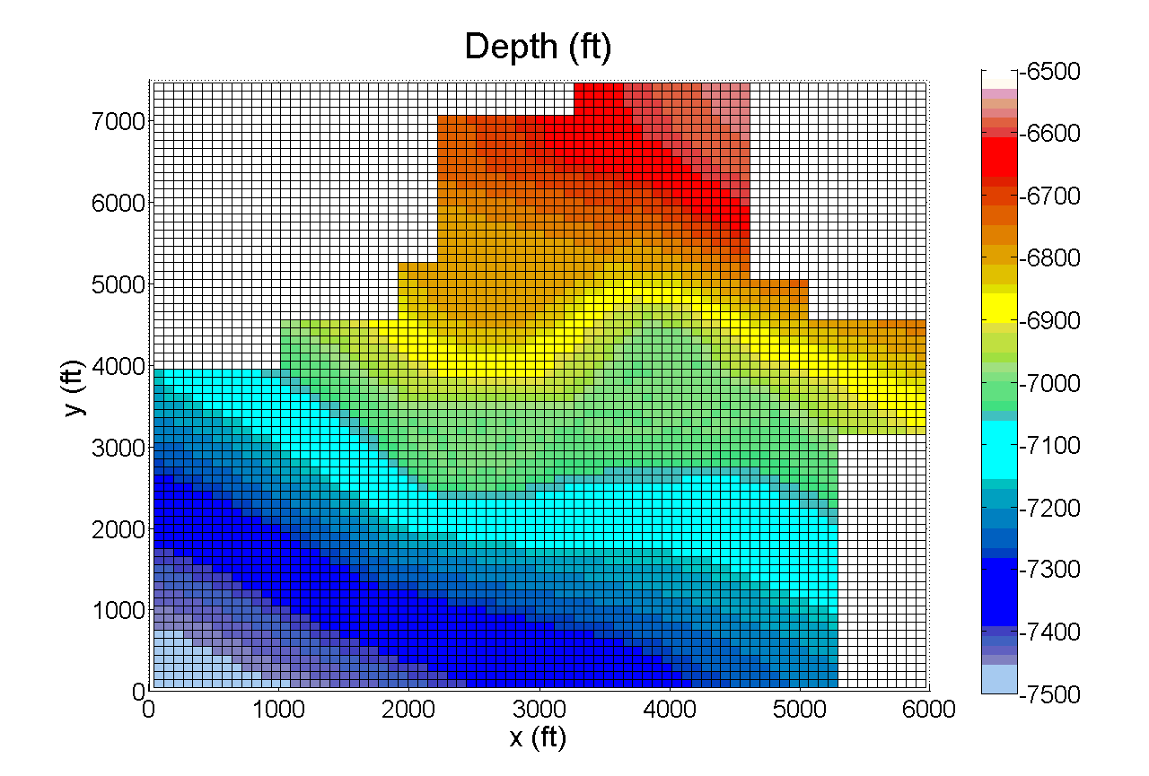

Figure 1: Reservoir depth

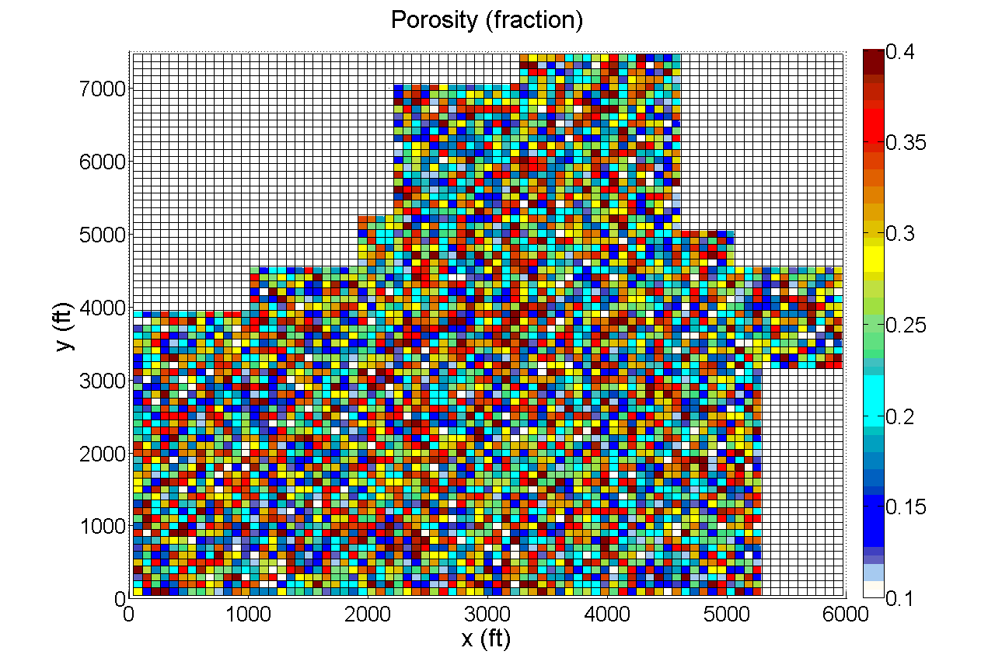

Figure 2: Reservoir porosity

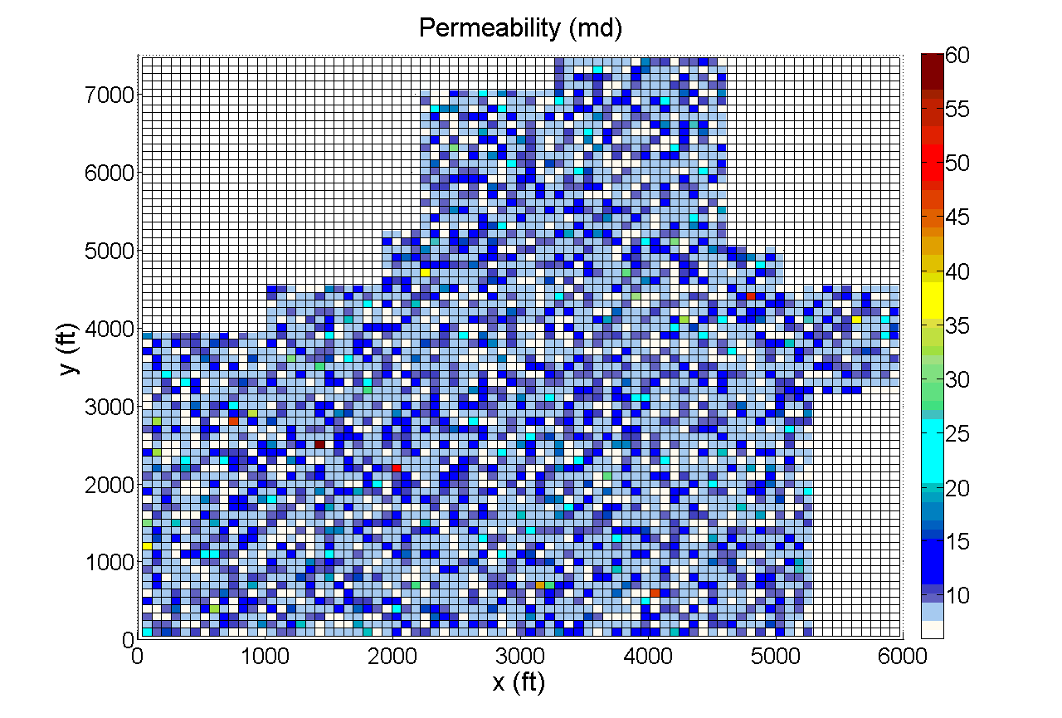

Figure 3: Reservoir permeability

Take the bottom left corner of the graph as the origin. The permeability in the x-direction is presented in the text file titled PJ1-Permeability.txt; the ratio of y-direction permeability to x-direction permeability is 0.15, and z-direction permeability to x-direction permeability is 1. The water oil contact (WOC) is located at a depth of 7474.45 ft (depth > WOC, Sw = 1) and the initial water pressure at this contact is 4500 psi.

The drainage (used for initialization) and imbibition capillary pressure functions are given by equation (1) and (2)

 (1a)

 (2a)

Take $P_{e}=3.5$, $S_{wcon}=0.2$, $S_{or}=0.4,$ and $λ=2$.

Except for initialization, use hysteresis scanning capillary pressure curve (J.E. Killough) given by equation (3) and (4).

 (3a)

 (4a)

Take EPSPC = .1.

Relative permeability functions are given by equation (5) and (6)

 (5a)

 (6a)

Take ${k_{rw}}^{o}=0.3$, ${k_{ro}}^{o}=0.8,$ $S_{wr}=0.2$, $S_{or}=0.4,$ and $n_{w}=n_{o}=2$.

Fluid properties for the fluids in this reservoir are given in Table 1 below:

**Table 1 : Fluid Properties**

|  |  |  |
| --- | --- | --- |
| Properties | Water | Oil |
| Formation Volume Factor (B) | 1.012298811 | 1.04567 |
| Reference Pressure for B [psi] | 4500 | PB = 502.505 |
| Compressibility (c) [psi-1] | 2.87 × 10-6 | 3 x 10-6 |
| B(P) |  |  |
| Solution Gas Oil Ratio (Rs) [ft3/bbl] |  | 90.7388 |
| Density (ρ) [lbm/ft3] | 62.4 | ρo=53, ρg=0.0458171 |
| Viscosity (μ) [cp] | .383 | 2.47097 |
| Viscosity pressure dependence [cp/psi] | 0 | 0.0001 |
| Reference Pressure for μ [psi] |  | PB = 502.505 |
| Bubble Point (BP) [psi] |  | 502.505 |
| Compressibility of Formation (cf) [psi-1] | 1x10-6 psi-1 | |

The wells in this reservoir are summarized in Table 2 below, the x and y coordinate of the wells are located in column 4 and 5 respectively:

Table : Well summary

|  |  |  |  |  |  |  |
| --- | --- | --- | --- | --- | --- | --- |
| **Well Number** | **Well Type** | **Well Condition** | **x (ft)** | **y (ft)** | **Rate (STB/d)** | **Pressure (psi)** |
| 1 | Vertical | Constant rate | 3637.5 | 5550 | 120 | 502.505 |
| 2 | Vertical | Constant rate | 3787.5 | 3550 | 90 | 502.505 |
| 3 | Horizontal | Constant pressure | 2475~2700 | 4350 |  | 502.505 |
| 4 | Horizontal | Constant pressure | 2175~2400 | 2650 |  | 502.505 |
| 5 | Vertical | Constant rate | 1087.5 | 1050 | 500 | 502.505 |
| 6 | Vertical | Constant rate | 412.5 | 3050 | 500 | 502.505 |

Radius is .25 ft and skin is 0 for all wells

Wells 1 and 2 start as constant rate producing wells (check column 6 of table 2 for their respective rates). If their BHP<502.505 psi, they are switched to a constant pressure well (P=502.505 psi). Wells 3 through 6 start as constant pressure producing wells (check column 7 of table 2 for their respective rates).

After 500 days well 1 and 2 are switched to constant pressure wells (if they have not already) with bottom-hole flowing pressure summarized in column 7 of table 2. Well 5 and 6 are converted into a constant rate injection well after 500 days with an injection rate of 500 STB/d.

Both horizontal wells are in the x-direction and 225 feet long (3 blocks total in length). You may weigh the horizontal well rates between blocks by total productivity index.

1. Use your program to generate a map of the pressure distribution at initial condition (t = 0 days), intermediate (500 days), (750 days) and late-time (1000 days). Slides 3-4
2. Use your program to generate a water saturation map at initial condition (t = 0 days), intermediate (500 days), (750 days) and late-time (1000 days). Slide 5-6
3. Make plots of the well rates for all the wells as functions of time (all on the same plot). Slide 7
4. Make plots of well water cut (%) for all the wells as a function of time (all on the same plot). Slide 8
5. Make plots of the bottom-hole pressure for all the wells as a function of time (all on the same plot). Slide 9
6. Fill the table in Slides 10-11
7. Provide a screen shot of the function file (or portion of the code) that computes interblock transmissibility including UPWINDING. I just need to see enough information to know how you completed this task (Slide 12)
8. Provide screenshot(s) of the the function file (or portion of the code) that shows how gravity and capillary pressure (imbibition) are included in the code (Slide 13)
9. Provide screenshot(s) of the the function file (or portion of the code) that computes the water and oil rates (e.g. water cut) in the code (Slide 14)